
MANUAL | LEE’S DISC METHOD
M/s TEXLA SCIENTIFIC INSTRUMENTS #3-3-593, CHAPPAL BAZAR, HYDERABAD – 500 027 MOBILE: 9440108331 , TELEFAX: 040- 24652326  Email ID: mail2texla@gmail.com. |  | CAT No: 1258

LEE’S METHOD EXPT
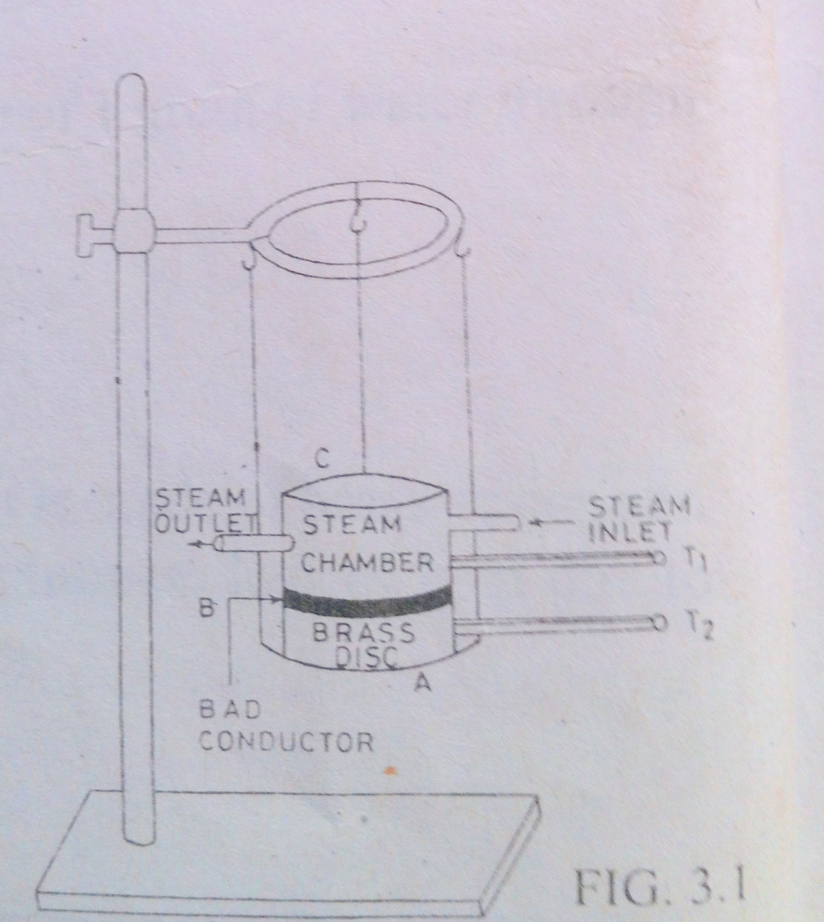
AIM: - To determine the coefficient of thermal conductivity of the material of a bad conductor, like card board, ebonite, glass etc., by Lee's method.
APPARATUS: - Lee's apparatus, steam generator, two thermometers, bad conductor in the form of a disc, screw gauge, Vernier calipers, rough balance and a stop watch.
FORMULA: -
Where
K=

K = coefficient of the thermal conductivity of the given bad conductor to be determined.
m = mass of the brass disc.
t = thickness of the bad conductor
d= thickness of the brass disc
r = radius of the brass disc
s= specific heat of the material of the brass disc (0.09 cal/gram/ º c)
ϴ₁= steady temperature of the steam chamber.
ϴ₂= steady temperature of the brass disc.
α= rate of cooling at the steady temperature ϴ₂ = dϴ/dt
DESCRIPTION: - Lee's apparatus consists of a thick nickel – coated brass disc A (Fig.1) suspended by three strings from a ring clamped to a stand, such that the faces of the disc are horizontal. The bad conductor B is placed between the disc A and the cylindrical brass steam chamber C. All the three A, B and C are of the same radius. The steam chamber is provided with two openings, one for admitting steam into it and the other for the exit of steam. A and C are each provided with a deep hole through which a thermometer can be inserted to note the temperatures
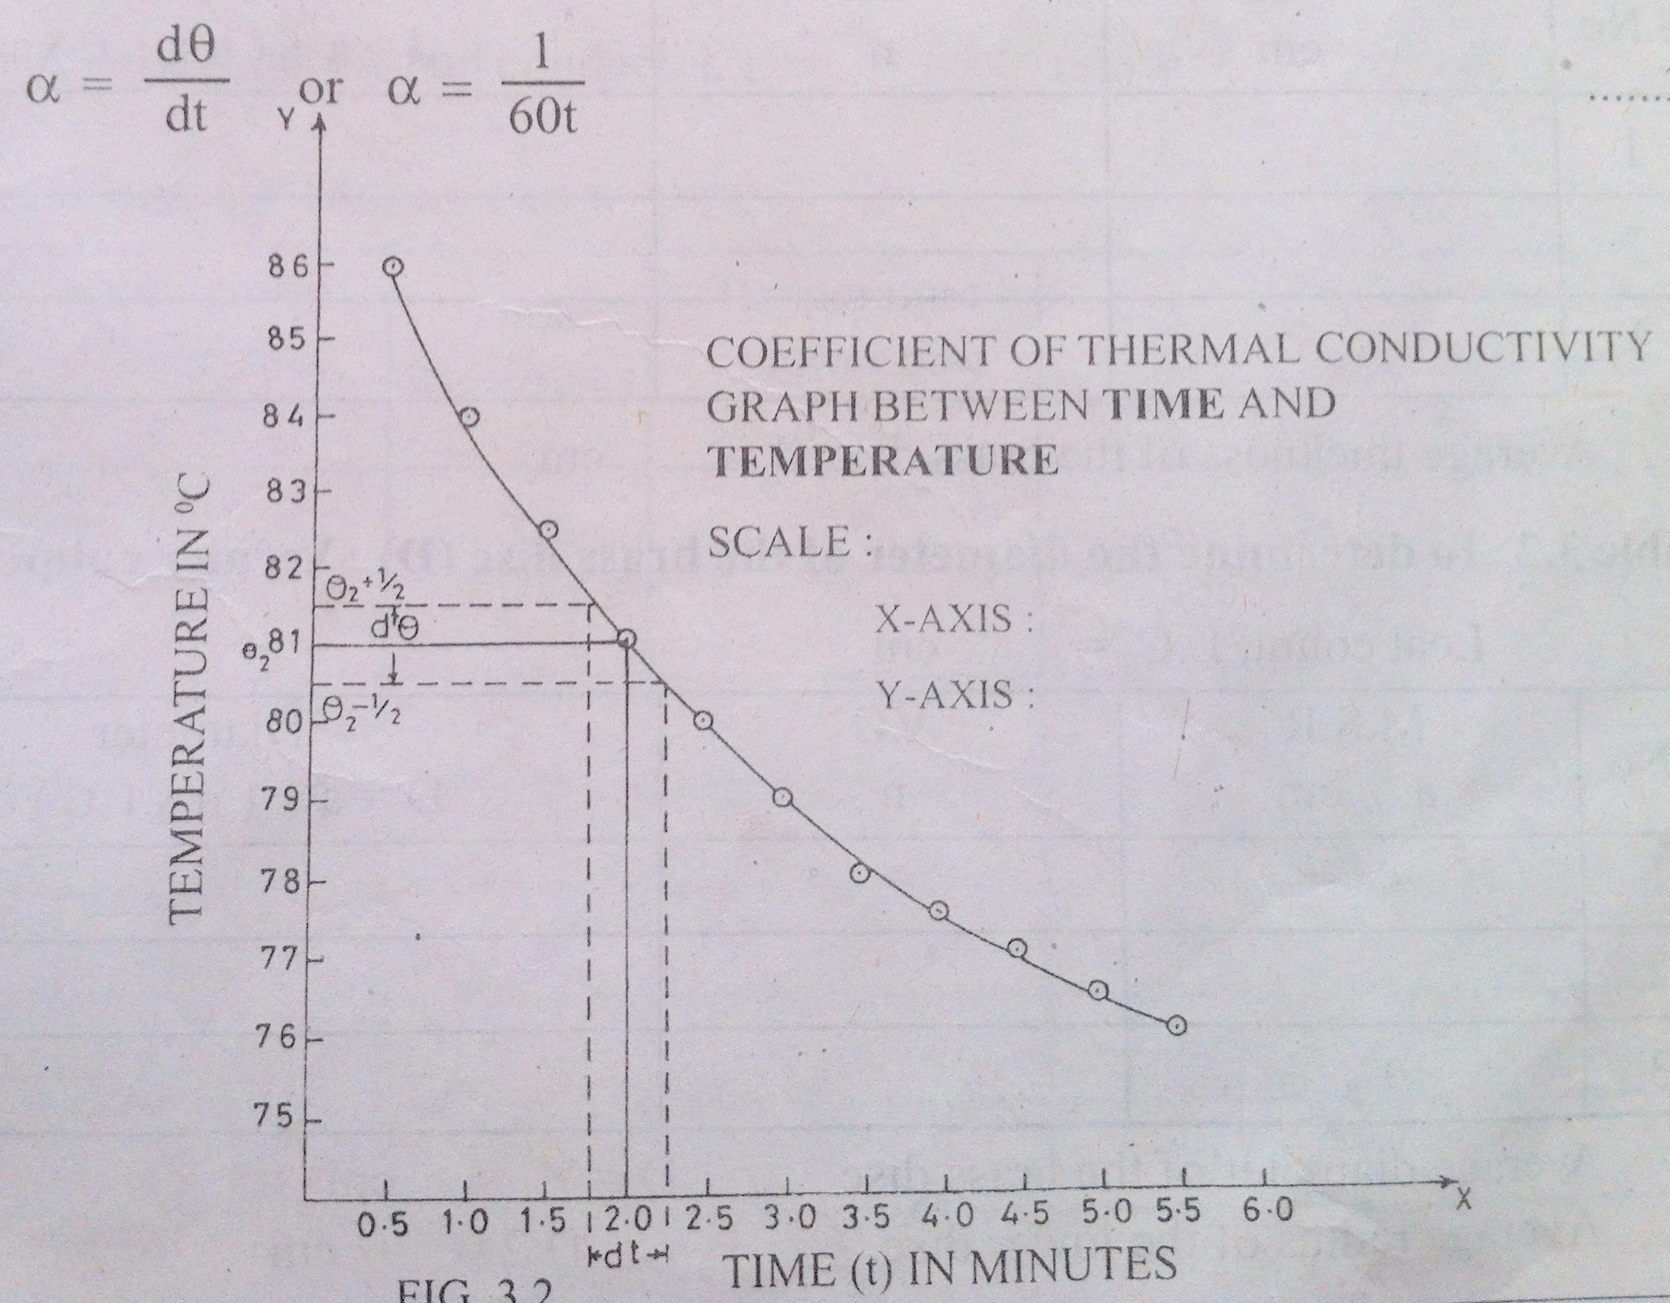
PROCEDURE: - Steam separately generated from a steam generator is circulated through the chamber C which consequently gets heated. Heat is conducted across the bad conductor and thus the brass disc A also gets heated. After sometime, the thermometers (T₁ and T₂) inserted in A and C indicates steady readings. Let these temperatures be ϴ₁ & ϴ₂ respectively. When this condition is reached the heat that enters the brass disc by conduction through the bad conductor per second is equal to the heat lost by the brass disc A due to radiation from its surface per second. Then we say that the system has attained a steady state. The above formula holds good only in steady state. Remove the bad conductor and place the steam chamber C directly on the brass disc A. The temperature of the brass disc A rises. When the temperature of the brass disc A rises by 5°C\ above the steady temperature ϴ₂, then remove the steam chamber C, start a stop watch and note the temperature of the brass disc A for every half a minute until the temperature falls (i.e. the disc cools due to radiation) to a temperature 5°C below its steadytemperatureϴ₂
Graph: - Draw a cooling curve with time on X-axis and temperature on Y-axis (Fig 2). The rate of cooling a of the brass disc at the steady temperature ϴ₂ can be found by any of the two methods.
First Method: - A curve as shown in Fig. 2 will be obtained. Draw lines at half degree above (ϴ₂ + 1/2) and half degree below (ϴ2-1/2) the steady temperature ϴ₂ of the brass disc, parallel to the x-axis. These two lines will meet the curve at two points. From the two
points, draw lines parallel to y-axis, which meet the x-axis at two points. The rate of cooling a of the brass disc at the steady temperature ϴ₂ can be obtained using the formula
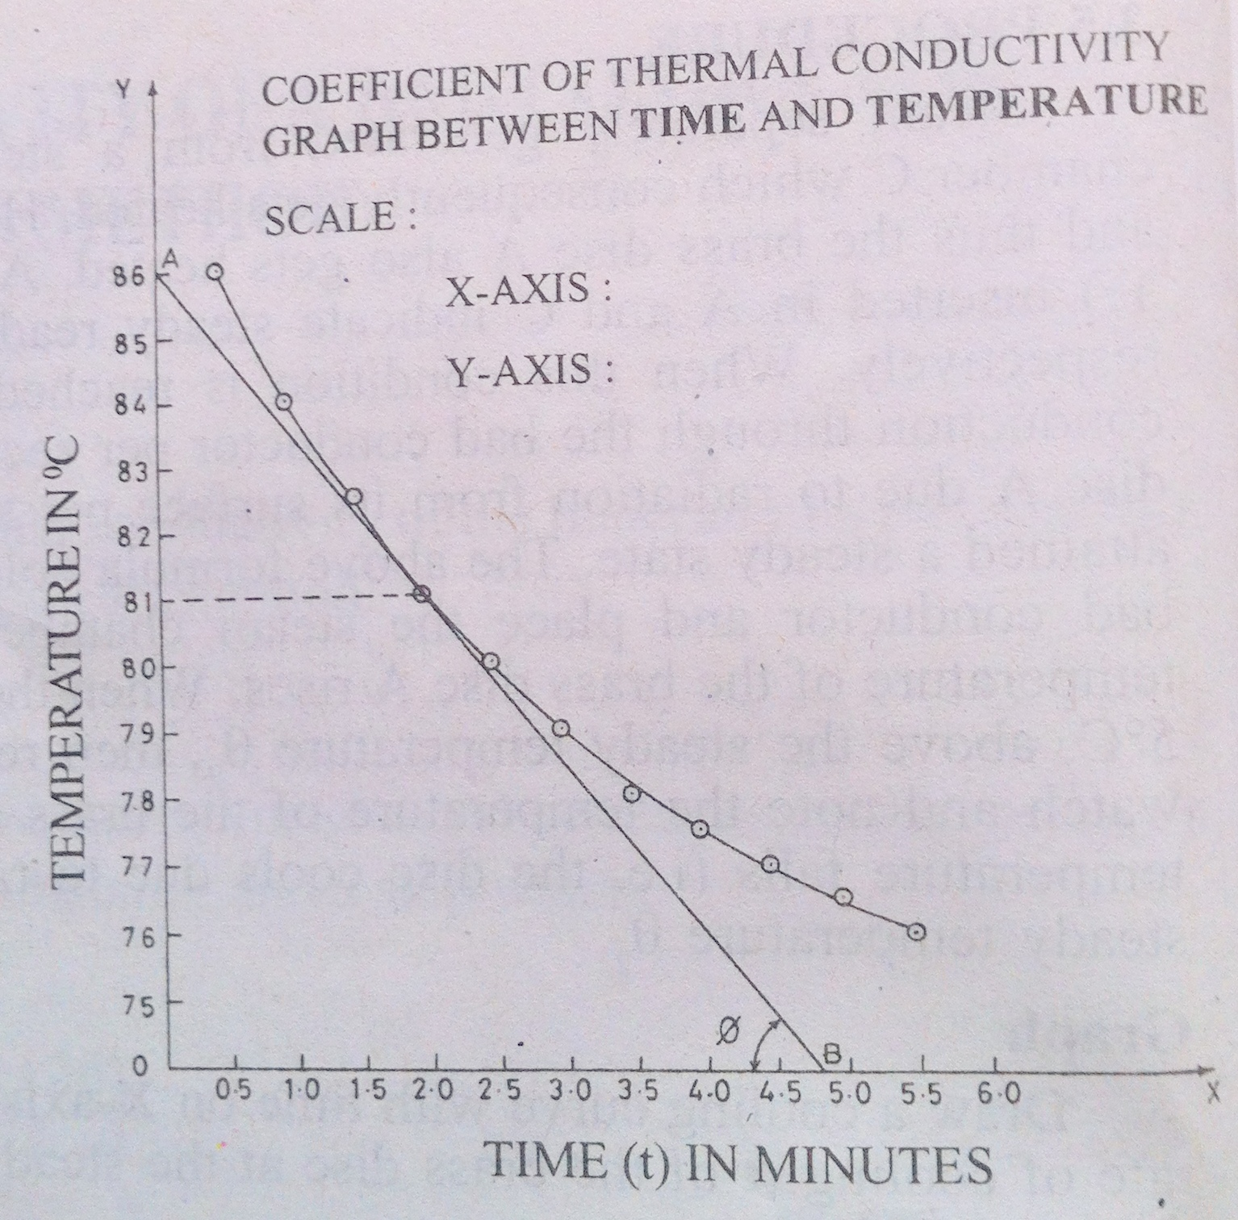
Second method: - At the steady temperature ϴ₂ of the brass disc, draw a line parallel to x-axis, which will meet the curve at one point (Fig. 3). Draw a tangent AB to the cooling curve at the steady temperature ϴ₂ of the brass disc. Then the rate of cooling a at the steady temperature can be found by the slope of the tangent i.e.,
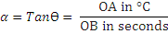
Observations: -
Table 1: To determine the thickness of brass disc (d): Vernier Calipers
Value of one main scale division S = mm
Total Number of division on the Vernier scale N =
Least count of the Vernier L.C = S/N = mm = cms
S.No | M.S.R (a) Cms | V.C (n ) | Thickness d= a+ (n x L.C) cm
Average thickness of the brass disc d= cm

Table 2: To determine the Diameter of brass disc (D): Vernier Calipers
Least Count L.C = cm
S.No | M.S.R (a) Cms | V.C (n ) | Thickness d= a+ (n x L.C) cm
Average Diameter of the brass disc D= cm
Average radius of the lower disc r = D/2 = cm
Table 3: To determine the thickness of bad Conductor (t): Screw guage
Number of divisions on the head scale:
Pitch of the screw = Distance moved on the pitch scale for n rotations
Number of rotations made by the headscale (n)
Least Count L.C = cm ; Zero error = divisions ; corrections = divisions
S.No | P.S.R  a mm | Head scale coincidence | Thickness  T= a+(n x L.C) mm
  Observed | Corrected (n)
Average thickness of the bad Conductor t = cm
Table 4: Reading for cooling curve
Time in minutes | Temperature of  Lower disc in⁰ C

Calculation of the rate of cooling (α)
From the graph α = dϴ/dt = ⁰ C/sec
Observed Values:

m = gm

t = cm

d= cm
r =cm
s= 0.09 cal/gram/ º c
ϴ₁= ⁰ C
ϴ₂= ⁰ C

K=
Result:
Coefficient of the thermal conductivity of the given bad conductor K = cal/sec/sq.cm/unit temperature gradient

